Project Documentation: Lead Generation Script

# 1. Introduction

This document explains a Python script designed to fetch business leads from Apify based on user inputs. The script searches for businesses in a specific state and industry, then saves the results in a JSON file.

# 2. What the Script Does

The script performs the following steps:

• Asks the user to input:  
 - A state (to search for businesses in that location).  
 - An industry (to filter businesses by type).  
• Connects to Apify (a web scraping and automation platform).

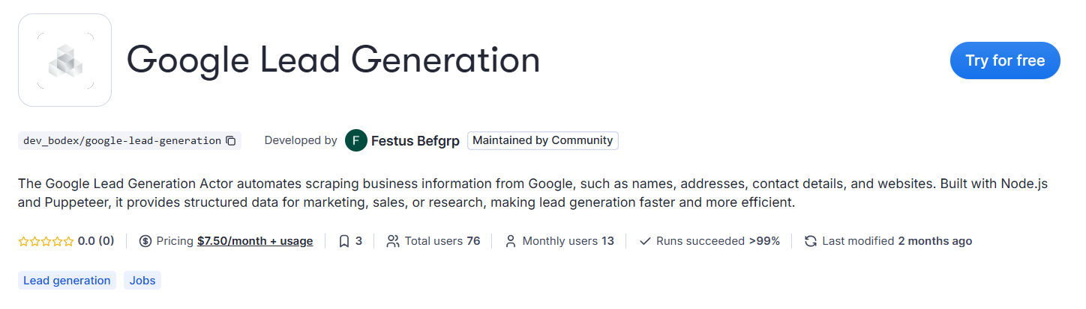

• Link to Google Lead Generation Actor is: <https://apify.com/dev_bodex/google-lead-generation>  
• Fetches business leads matching the inputs.  
• Saves the results in a file named actor_results.json.

# 3. How to Use the Script

Prerequisites

• A computer with Python installed.  
• An Apify account (to use their API).  
• The script file (script.py).

Steps to Run the Script

1. Open the script in a code editor or terminal.  
2. Run the script (usually by typing `python script.py` in the terminal).  
3. Enter the required inputs when prompted:  
 - State: (e.g., "California")  
 - Industry: (e.g., "Restaurants")  
4. The script will fetch the data and save it in actor_results.json.

# 4. Explanation of the Code

1. Importing Required Libraries

*from apify_client import ApifyClient  
import json*  
  
• ApifyClient → Used to connect to Apify’s API.  
• json → Helps in saving data in JSON format.

2. Setting Up the Apify Client

.env file contains the variables to set.

*client = ApifyClient(os.getenv("APIFY_API_KEY"))*  
This connects to Apify using an API key (a secret code for authentication).

3. Taking User Inputs

*area = input("In which state do you want to search the leads?\n")  
query = input("Write the specific industry to get leads for.\n ")*  
  
Asks the user for a state and industry to search for leads.

4. Running the Apify Actor (Automation Task)

*run_input = {  
 "area": area,  
 "search": query,   
}  
  
run = client.actor("FK0MkqvI0wudAJ1fK").call(run_input=run_input)*  
Sends the user inputs to Apify, which then searches for matching businesses.

5. Saving the Results

*items = []  
for item in client.dataset(run["defaultDatasetId"]).iterate_items():  
 items.append(item)  
  
with open("actor_results.json", "w") as f:  
 json.dump(items, f, indent=4)  
  
print("Results saved to actor_results.json")*  
  
Collects all the leads and saves them in a JSON file (actor_results.json).  
The file will contain details like business names, addresses, phone numbers, etc.

# 5. Expected Output

After running the script:

• A file named actor_results.json will be created.  
• It will contain a list of businesses matching the search criteria.

Example of what the file may look like:

*[  
 {  
 "name": "ABC Restaurant",  
 "address": "123 Main St, California",  
 "phone": "+1 555-1234",  
 "website": "https://abcrestaurant.com"  
 },  
 {  
 "name": "XYZ Diner",  
 "address": "456 Oak Ave, California",  
 "phone": "+1 555-5678",  
 "website": "https://xyzdiner.com"  
 }  
]*

# 6. Troubleshooting

If the script doesn’t run:

• Ensure Python is installed (check using `python --version` in terminal).  
• Check if the Apify API key is valid.

If no results appear:

• Try a different state or industry name.  
• Ensure the Apify actor (automation task) is working.

# 7. Conclusion

This script simplifies lead generation by fetching business data from Apify based on user inputs. The results are saved in an easy-to-read JSON file for further use.  
  
For any issues, contact the developer or Apify support.